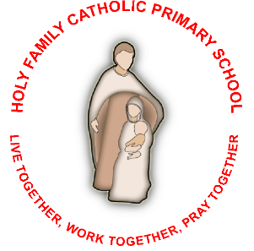
Statement of Ethos and Values

Aims and Objectives of our School Community
- To follow Jesus in sharing God’s love for all creation
- To experience and reflect upon a sense of belonging to a wider world
- To nurture a sense of love for God and neighbour
- To work together to grow in faith
- To be the face of Christ to all we meet
- To enjoy praying and praising God
- To provide opportunities and experiences for all to reach their potential
- To recognise the uniqueness of all and their talents and the contribution they make
- To provide an enjoyable, broad and inclusive curriculum
- To foster the skills of resilience, creativity, problem solving and independence
- To learn through listening, sharing ideas, trying our very best
- To encourage all children to have faith and seek help when they are finding something difficult
- To understand our roles and responsibilities to ourselves and others in a diverse world
- To ensure that all children know how to keep themselves safe, healthy, self-disciplined and motivated to be good citizens and make a positive contribution
- For all children to have respect for themselves and each other and develop an awareness of their responsibilities towards the communities that they are a part of

