
Behaviour: Relationship and Regulation Policy

Introduction
Relationships build our self-esteem and develop our sense of belonging. We aim in this policy to create a simple and effective system which builds skills for life. Best practice is embedded to promote growth, provide opportunities to the children to reflect and develop skills including, communication, confidence, resilience and independence. This policy is a working document which will develop organically overtime via input from pupil voice, staff voice and community engagement.
The following key principles contribute to the ethos of Holy Family Catholic Primary School being Faith, Family, Friendship.
Our aim is that our school is a place everyone loves to be because they feel: SAFE, SEEN, SOOTHED and SECURE
Key Principals | Examples of Best Practice
We recognise that behaviour is communication and we seek out ways to address underlying factors.  We recognise all emotions as normal and valid.  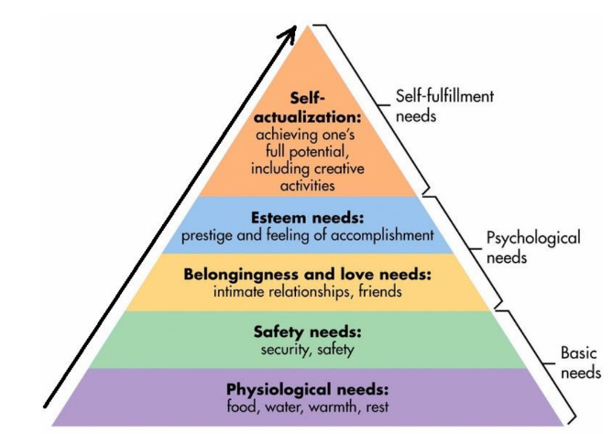  Maslow’s Hierarchy of Needs | Examples of best practice are to be used for guidance and will be added to over time.  - Emotional coaching CPD  - Attachment CPD  - Bubble Mentorship (formal and informal)  - Coaching & INSET days  - Teaching behaviour & self-regulation strategies  - Self-nomination; performance management
Our children feel SEEN | 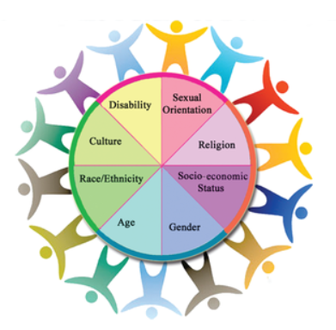  Rewards are at the discretion of the classroom teacher and staff, preferably with discussion and input from their pupils.  Pupil voice collected in 2024 shows that our pupils responded most positively to the following:  - Visible reward system e.g. gold, platinum, shooting stars, rainbow, traffic lights, etc on walls and in classrooms  - Dojo points  - Rewards are given (not taken away) e.g. raffles, dojo points, stickers, prizes, etc.  - Changing ‘time out’ into a Relationships & Regulation Station, where pupils will use strategies to help them become ready to return to learning/class activities  - Using areas within school as Relationships & Regulation areas, where pupils will use strategies to help them become ready to return to playtime and return to learning time after play. Staff may wish to pilot something new of their own choice, or carry on with tried and true methods or adopt best practice from other colleagues.
Our children feel SECURE | We create opportunities for student leadership: Mini Police, School council, House captains (Y6), Sports leaders, assigning roles and responsibilities in the classroom and special jobs created just for them.  These may change year to year to match school and pupil needs.  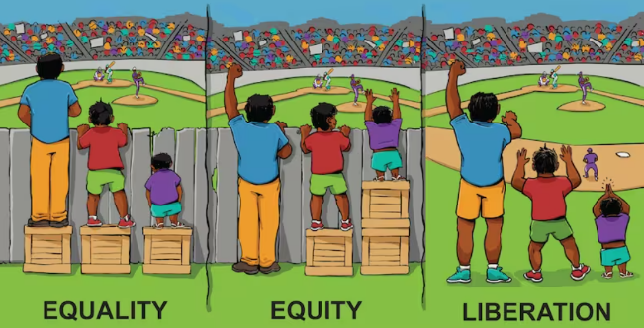  We strive to remove barriers to achievement so that we are doing our very best for all children.
Our children feel SOOTHED | - Emotional coaching and Regulation  - We use I statements: “I feel … because …”  - Colour monsters  - Resilience books  - Relationships and Regulation displays/areas in the class  - Relationships & Regulation station outside for support during playtimes  - Stress-busting strategies  - Breathing and stretching techniques  - Sensory Diet  - Wigan Family Welfare, TESS, Place2Be  - Mental Health Lead

Regulation & Self-regulation
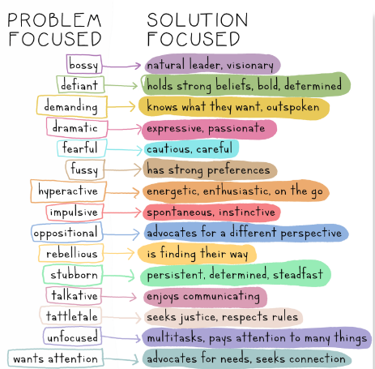
At Holy Family Catholic Primary School, we believe that teaching children to regulate their own behaviour and to pursue positive relationships is more constructive than a system of sanctions and punishments. We aim to focus on solutions rather than problems:

Required Regulation Approach for PLAYTIMES and LUNCHTIMES:
- Emotion coaching (encourage pupils to identify and share their feelings, facilitate “I feel …because …” conversations)
- Reminder of rules, rights and responsibilities
- Regulation station on friendship bench
- Regulation station in Regulation Room (a calm place designed for introspection)
- Regulation with a member of staff (emotion coaching and recording of the situation)
Note: Stages can be escalated/skipped if someone is in danger

Recommended CLASSROOM regulation steps:
- Emotion coaching (e.g. direct a pupil to the emotion monsters on the wall, encourage them to identify and share their feelings, facilitate “I feel … because …” conversations)
- Reminder of rules, rights & responsibilities
- Regulation station in the classroom (a calm place designed for introspection)
- Regulation station in another classroom (as above)
- Regulation with a member of SLT (emotion coaching and support to reflect on the situation)
Note: Stages can be escalated/skipped if someone is in danger
This policy will meet the requirements of the Children Act 1989, SEN/Disability Act 2001/2005, The
Children's Act 2004, Education and Inspections Act 2006.

This policy should be read in conjunction with Holy Family Catholic Primary School’s policies on: Positive Handling, Exclusions, Safeguarding and Equality Act 2010 (Inclusion and Equality Plan and Objectives).

This policy replaces the “behaviour policy” and acknowledges the school's legal duties under the Equality Act 2010 and in respect of pupils with special educational needs (SEN). We recognise that some pupils will need tailored support with their relationships and regulation at different points.

Personalised plans can then be created collaboratively with parents, class teachers, SENDCO, school leaders and the children themselves.

