Pupil premium strategy statement December 2025

This statement details our school’s use of pupil premium funding to help improve the attainment of our disadvantaged pupils.
It outlines our pupil premium strategy, how we intend to spend the funding in this academic year and the outcomes for disadvantaged pupils last academic year.

School overview
Detail | Data
Number of pupils in school September 2025 | 212
Proportion (%) of pupil premium eligible pupils September 2024 | 12%
Academic year/years that our current pupil premium strategy plan covers | 3 Year Plan
Date this statement was published | December 2025
Date on which it will be reviewed | November 2026
Statement authorised by | Mr. M B McDonald
Pupil premium lead | Mrs. C Roberts
Governor / Trustee lead | Standards Committee

Funding overview
Detail | Amount
Pupil premium funding allocation this academic year | £ 39390
Pupil premium funding carried forward from previous years (enter £0 if not applicable) | £0
Total budget for this academic year  If your school is an academy in a trust that pools this funding, state the amount available to your school this academic year | £ 39390

Part A: Pupil premium strategy plan

Statement of intent
When making decisions about using Pupil Premium funding it is important for Holy Family Catholic Primary School to consider the context of the school and the subsequent challenges faced alongside research conducted by the EEF.
Common barriers to learning for disadvantaged children can be: less support at home, weak language and communication skills, lack of confidence, more frequent behaviour difficulties and attendance and punctuality issues. There may also be complex family situations that prevent children from flourishing. The challenges are varied and there is no “one size fits all”.
We will ensure that all teaching staff are involved in the analysis of data and identification of pupils, so that they are fully aware of strengths and weaknesses across the school.

Principles
- We ensure that teaching and learning opportunities meet the needs of all the pupils
- We ensure that appropriate provision is made for pupils who belong to vulnerable groups, this includes ensuring that the needs of socially disadvantaged pupils are adequately assessed and addressed
- In making provision for socially disadvantaged pupils, we recognise that not all pupils who receive free school meals will be socially disadvantaged
- We also recognise that not all pupils who are socially disadvantaged are registered or qualify for free school meals. We reserve the right to allocate the Pupil Premium funding to support any pupil or groups of pupils the school has legitimately identified as being socially disadvantaged.
- Pupil premium funding will be allocated following a needs analysis which will identify priority classes, groups or individuals. Limited funding and resources means that not all children receiving free school meals will be in receipt of pupil premium interventions at one time.
- Our approach will be responsive to common challenges and individual needs, rooted in robust diagnostic assessment, not assumptions about the impact of disadvantage. The approaches we have adopted complement each other to help pupils excel. To ensure they are effective we will:
- Ensure disadvantaged pupils are challenged in the work that they’re set
- Act early to intervene at the point need is identified
- Adopt a whole school approach in which all staff take responsibility for disadvantaged pupils’ outcomes and raise expectations of what they can achieve.

Demography and School Context
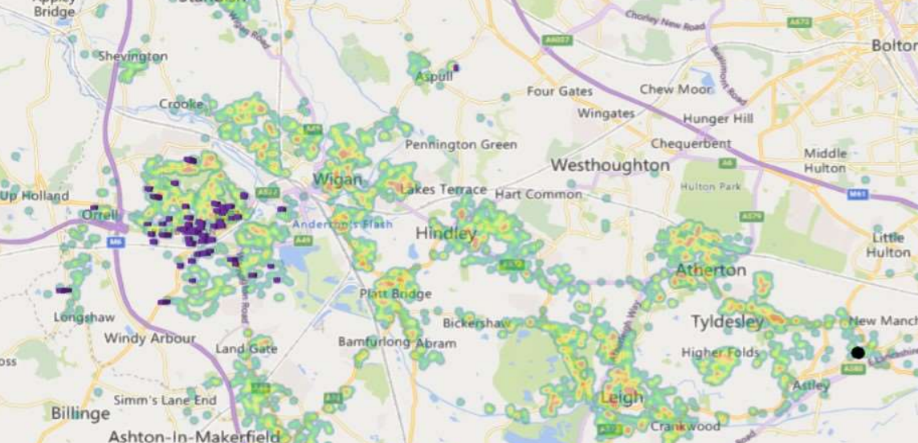

- The heat map shows FSM eligibility for all pupils in Reception - Year 6 across Wigan. Data used in this section has been produced using January 2025 Census data and year groups mentioned are those as of January 2025

Ultimate Objectives
- To narrow the attainment gap between disadvantaged and non-disadvantaged pupils nationally and also within internal school data.
- For all disadvantaged pupils in school to exceed nationally expected progress rates in order to reach Age Related Expectation at the end of Year 6 and thus achieve GCSE’s in English and Maths.
- Achieving These Objectives
- This details the key challenges to achievement that we have identified among our disadvantaged pupils.
1 Weak Language and Communication skills
2 Low attainment on entry to the Early Years Foundation Stage in all areas
3 More frequent behaviour/emotional difficulties.
4 Attendance and Punctuality issues.
5. Barriers to accessing online learning
- The range of provision the Governors consider making for this group include and would not be limited to:
- 1-1 support where assessments and monitoring highlight the need
- Additional teaching and learning opportunities provided through trained Teaching assistants or external agencies
- All our work through the pupil premium will be aimed at accelerating progress, moving children to at least age-related expectations and beyond where appropriate
- Pupil premium resources are to be used to target able children on Free School Meals to achieve Age Related Expectations
- Transition from primary to secondary and transition internally and into EYFS.
- Additional learning support.
- Pay for activities, educational visits and residentials, ensuring children have first-hand experiences to use in their learning in the classroom.
- Support the funding of specialist learning software.
- To extend PE provision to play, lunchtimes and afterschool.
- To allow the children to learn a musical instrument.
- Behaviour and nurture support during lunchtimes by providing activities to engage and promote Gospel values and thus enhance learning.

This list is not exhaustive and will change according to the needs and support our socially disadvantaged pupils require.

Challenges
This details the key challenges to achievement that we have identified among our disadvantaged pupils.
Challenge number | Detail of challenge
1 | Continuing raising standards in Speech and Language, Phonics, Reading and Writing outcomes  Assessments, observations, and discussions with pupils indicate underdeveloped oral language skills and vocabulary gaps among many disadvantaged pupils. These are evident from Reception and are more prevalent among our disadvantaged pupils than their peers.
2 | Low attainment on entry to the Early Years Foundation Stage in all areas and GLD outcomes for Disadvantages Pupils in Reception  Assessments, observations, and discussions with pupils suggest disadvantaged pupils generally have greater difficulties on entry to reception than their peers.  On entry to Reception class in the last 3 years, between 80 - 100% of our disadvantaged pupils arrive below age-related expectations. This gap narrows but remains significant to the end of KS1.
3 | More frequent behaviour/emotional difficulties.  Our assessments, observations and discussions with pupils and families have identified social and emotional issues for many pupils. These challenges particularly affect disadvantaged pupils and those with dual need, including their attainment.  Teacher referrals for support remain high in EYFS and KS1. As of September 2025, there are 34 active provisions in place for specialist school support with 9 of these being for social/emotional and mental health interventions. Of those, 10% are disadvantaged and currently require additional support with social and emotional needs, receiving small group interventions, 1- support and counselling. Numbers are decreasing over the years of support being in place and significantly reduce as pupils enter upper KS2, evidencing impact.
4 | Attendance and Punctuality.  Our attendance data indicates that attendance among disadvantaged pupils has been broadly in line of that for non-disadvantaged pupils.  This data shows that strategies that have been in place have had the desired impact and therefore are an integral part of school’s actions to tackle absenteeism.
5 | Children completing homework and reading at home  Assessments, observations, and discussions with pupils suggest disadvantaged pupils generally have greater difficulties completing homework than their peers. This includes reading, online activities and more formal written work.

Intended outcomes
This explains the outcomes we are aiming for by the end of our current strategy plan, and how we will measure whether they have been achieved.
Intended outcome | Success criteria
Progress in Reading | Achieve at least national average progress scores in KS2 Reading
Progress in Writing | Achieve at least national average progress scores in KS2 Writing
Progress in Maths | Achieve at least average progress scores in KS2 Maths
Phonics | Achieve above national average expected standard in PSC
To ensure attendance is in line or exceeding national expectations | Ensure attendance of disadvantaged pupils is above 96%
To equip pupils to be confident and  resilient | Pupils will have increased confidence to  voice their opinions in lessons/  assemblies/performances through increased opportunities to develop oracy skills
That pupils will enjoy healthy relationships and develop strategies to resolve conflict | Reduction in recorded incidents of falling out.  Increased number of pupils able to manage conflicts
To improve standards of attainment in Maths and English, particularly communication | Progress is accelerated so that the gap reduces between PPG and Non-PPG pupils
To ensure all children have the ability to consolidate areas of learning and read frequently (daily) and complete homework | All children completing homework  Daily reading in place for the bottom 20%  Access to a range of books, including those celebrating protected characterises, are available to all children

Activity in this academic year
This details how we intend to spend our pupil premium funding this academic year to address the challenges listed above.

Teaching (for example, CPD, recruitment and retention)
Budgeted cost: £28928
Activity | Evidence that supports this approach | Challenge number(s) addressed
Purchase of standardised diagnostic assessments.  Training for staff to ensure assessments are interpreted and administered correctly.  £1,000 | When used effectively, diagnostic assessments can indicate areas for development for individual pupils, or across classes and year groups:  Diagnostic assessment | EEF | 1, 2, 3, 4
Continue to embed a DfE validated Systematic Synthetic Phonics programme (Sounds Write) to secure stronger phonics teaching for all pupils.  Commitment to purchasing high quality training for staff.  Further develop work in line with English HUb  £200 Books | Phonics approaches have a strong evidence base that indicates a positive impact on the accuracy of word reading, particularly for disadvantaged pupils:  Phonics | Teaching and Learning Toolkit | EEF | 2, 4
Embedding dialogic activities across the school curriculum. These can support pupils to articulate key ideas, consolidate understanding and extend vocabulary. We will purchase resources and fund ongoing teacher training and release time where highlighted as a need. | There is a strong evidence base that suggests oral language interventions, including dialogic activities such as high-quality classroom discussion, are inexpensive to implement with high impacts on reading:  Oral language interventions | Teaching and Learning Toolkit | EEF
Enhancement of our maths teaching and curriculum planning in line with DfE and EEF guidance.  We will fund teacher release time to embed key elements of guidance in school and to access Maths Hub resources and CPD (including Teaching for Mastery training).  £2,000 | The DfE non-statutory guidance has been produced in conjunction with the National Centre for Excellence in the Teaching of Mathematics, drawing on evidence-based approaches:  Mathematics_guidance: key stages 1_and 2  The EEF guidance is based on a range of the best available evidence:  Improving Mathematics in Key Stages 2 and 3
Deputy Head designated teacher for the teaching of reading and writing in Year 4 with class teachers supporting. Allowing CPD for staff and high level of experienced teaching to be in place  (£25,728) | Both targeted interventions and universal approaches can have positive overall effects:  Behaviour interventions | Teaching and Learning Toolkit | EEF

Targeted academic support (for example, tutoring, one-to-one support, structured interventions)
Budgeted cost: £ 12595.95
Activity | Evidence that supports this approach | Challenge number(s) addressed
Additional Boosting for pupils in Year 6 to support secondary readiness  (After school:  4 teachers))  During school x2 teachers  £0 | targeted at specific needs and knowledge gaps can be an effective method to support low attaining pupils or those falling behind, both one-to-one:  One to one tuition | Teaching and Learning Toolkit | EEF  And in small groups:  Small group tuition | Teaching and Learning Toolkit | EEF | 1,2,3,4
Additional phonics sessions targeted at disadvantaged pupils who require further phonics support.  2 teaching assistant 1.5 hours x5:  £12595.95 | Phonics approaches have a strong evidence base indicating a positive impact on pupils, particularly from disadvantaged backgrounds. Targeted phonics interventions have been shown to be more effective when delivered as regular sessions over a period up to 12 weeks:  Phonics | Teaching and Learning Toolkit | EEF | 2
Continued implementation of WellComm programme to improve listening, narrative and vocabulary skills for disadvantaged pupils who have relatively low spoken language skills.  £0 | Oral language interventions can have a positive impact on pupils’ language skills. Approaches that focus on speaking, listening and a combination of the two show positive impacts on attainment:  Oral language interventions | Teaching and Learning Toolkit | EEF | 1, 4

Wider strategies (for example, related to attendance, behaviour, wellbeing)
Budgeted cost: £ 10799.49
Activity | Evidence that supports this approach | Challenge number(s) addressed
Morning health and well-being sessions for children with identified mental health/attendance concerns in upper KS2  £3700 | Both targeted interventions and universal approaches can have positive overall effects:  Behaviour interventions | Teaching and Learning Toolkit | EEF | 5
Mental Health focus within teaching and learning with the aim of developing our school ethos and improving mental health and well-being across school. | Both targeted interventions and universal approaches can have positive overall effects:  Behaviour interventions | Teaching and Learning Toolkit | EEF | 5
Embedding principles of good practice set out in the DfE’s guidance on working together to improve school attendance.  This will involve training and release time for staff to develop and implement new procedures and appointing attendance/support officers to improve attendance.  Attendance Review  Weekly  Termly attendance  • Newsletters  • Termly  - EPN  - Attendance letters/Arbor Emails  £100  Attendance SLA | The DfE guidance has been informed by engagement with schools that have significantly reduced levels of absence and persistent absence. | 6
Targeted social and emotional support for identified children at the end of the school day to support home transition  Teaching assistant  .5 hours x5:  £1679.49 | Both targeted interventions and universal approaches can have positive overall effects:  Behaviour interventions | Teaching and Learning Toolkit | EEF | 5
Purchase of counselling service to support identified pupils (WFW)  £4,820 | Both targeted interventions and universal approaches can have positive overall effects:  Behaviour interventions | Teaching and Learning Toolkit | EEF | 5
Further develop relationship with CAMHS School nurse to ensure pupils and parents can access suitable support through school | Both targeted interventions and universal approaches can have positive overall effects:  Behaviour interventions | Teaching and Learning Toolkit | EEF | 3,4, 5

Total budgeted cost: £ 52323.44

Part B: Review of the previous academic year

Outcomes for disadvantaged pupils
Challenge 1 and 2
Attainment data from Summer 2025 demonstrate that pupil premium pupils achieved the following at expected or above.
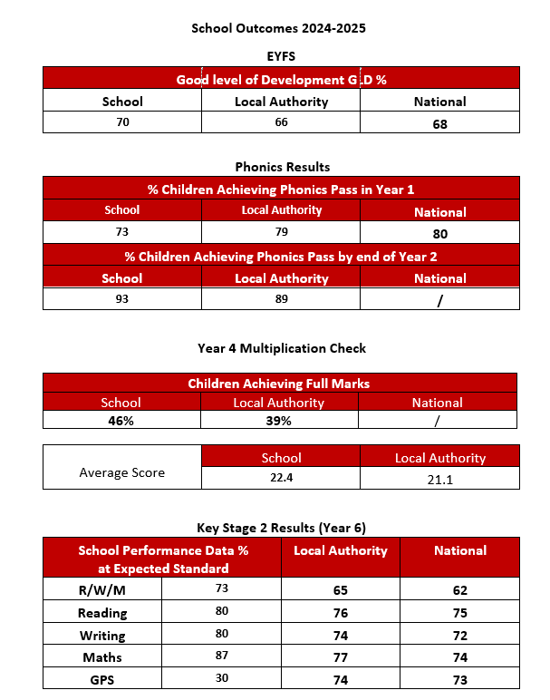

Results for Disadvantaged Pupils 2023-2024
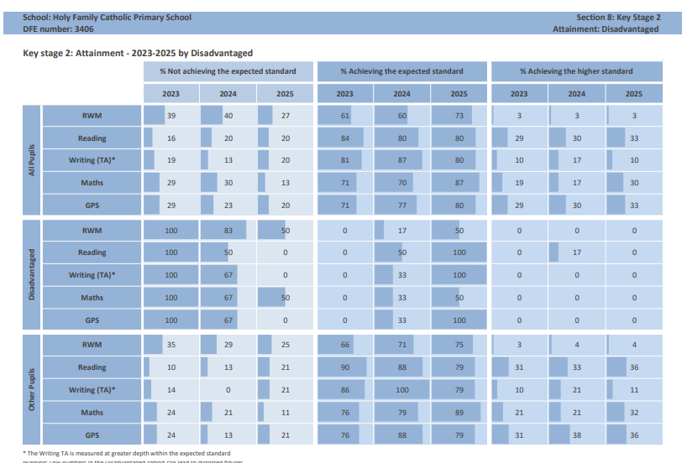
Attendance compared to similar schools
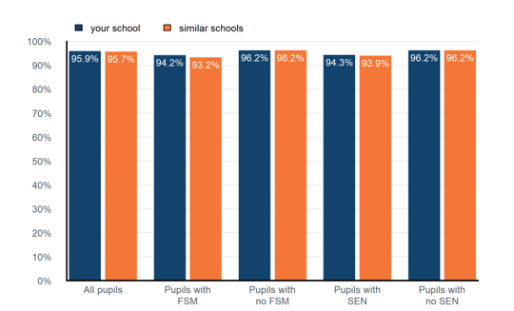

Pupil group | Attendance 2024/5 | Attendance 2025/6
All pupils | 96.5% | 96%
Pupils with FSM | 94.3% | 94%
Pupils with no FSM | 96.9% | 96.3%
Pupils with SEN | 95.2% | 95%
Pupils with no SEN | 96.8% | 96.1%

Challenge 3 and 4
Wigan Family Welfare provided support through the graduated response to 11 children and is also used as a reactive service when this is required through circumstances which we may not be able to plan for in a young person’s life
Bereavement Counselling was provided where appropriate
Without this support and that of BH Sports, the school would have faced school avoidance, low level disruption and children who may have required access to further support from CAMHS.
Work with the Behaviour Team (TESS) also supported parental engagement and enabled support to be swift and targeted at the time of needed rather than waiting for referrals to be triaged and the offer of follow up appointments which have proven to be lengthy.

Attendance was above national for all groups and this was due to the support of parents, the curriculum offer which continued to be broad and balanced and the wider curriculum which identified 1-1 support.
Newsletters and Class Dojo noticeboard provided information for parents. Feedback was positive and parents felt this helped to more connected to school life
Workshops for parents were well attended and provided valuable information and support for phonics and maths.
Wider opportunities included but were not limited to:
PE Taught by BH Sports 2 lessons per year group each week
Music Taught by Minshall Music – All classes
Wider Opportunities: Year 4
Spanish taught by Primary Language Network – All classes
Enrichment
- Pantomime all children
- Tri Kidz 1 session all pupils
- Boxing 1 session all pupils
- Dance 7 sessions all pupils
- Judo 7 sessions before school club
- Archery 7 sessions before school club
- Science week – all pupils
- Cafod Fundraising Harvest Festival All children
- Cafod Stamp out Hunger challenge – All children 40 days of Lent
- World Book Day – all pupils
- All classes have taken part in off-site visits
- Y6 5 day residential to Low Bank Ground
- After school sport clubs available each night
- Competitive inter school sports: Football, netball, mixed football, girls football, swimming, kurling, hockey, basketball.
- Intra school competitions
- Nativities
- Class led assemblies for families
- Class led Collective Worships for families
- Year 4 First Holy Communion and Reconciliation.
- Spanish all year groups
- Drumming – Year 4
- Swimming Year 3
- Grandparents afternoon tea
- Proms on the Playground
- Police visit Year 6 and Year 5 x 3
- Forest School (Year 1 and 2 )
- Bikeability and Balancability
- Mental Health Workshops
- HH Kidz
- Young Voices

Externally provided programmes
Please include the names of any non-DfE programmes that you used your pupil premium to fund in the previous academic year.
Programme | Provider
WellComm | WellComm
Spelling Shed | Literacy Shed Plus
Purple Mash | 2 simple
Timetables Rockstars | Baz Winter
Accelerated Reader | Renaissance learning
Sounds Write | Sounds Write

Service pupil premium funding
For schools that receive this funding, you may wish to provide the following information: How our service pupil premium allocation was spent last academic year
None
The impact of that spending on service pupil premium eligible pupils
N/A

